  - Contact: Kari Veenstra | Phone: 616-915-2362 | kariveenstra.author@gmail.com
  - FOR IMMEDIATE RELEASE
  - Exploring Oppression and Prejudice 500 Feet Underwater
Class systems and natural prejudices take center stage in novel penned by El Paso author.
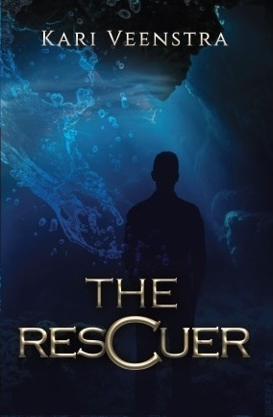
El Paso, Texas, Feb 2020—Local author Kari Veenstra launches her debut novel. Titled The Rescuer, the science-fiction/fantasy adventure revolves around the controversial topics of class systems and natural prejudices taking place in a world entrenched in systematic oppression.
500 feet below the surface of a drowned planet where worth is measured by occupation, and some citizens have more value than others, a plucky 15-year-old underdog risks his one chance at a better future to track down his missing best friend. But the gamble costs more than he bargained for, and choice comes with permanent consequences.
The Rescuer is a heart-rending adventure that deals with family, friendship, and sacrifice, and is targeted at readers who love Rick Riordan-style adventures and space fantasy along the veins of Star Wars. The book is available for purchase at https://bit.ly/2uS6nPs; the original trade paperback and hardcover are available from Ingram; and the e-book is available from Amazon.

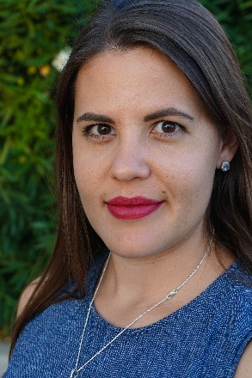
Author Bio: KARI VEENSTRA writes gripping adventure novels for teens allowing them to escape into the world of fiction while still being confronted with the tough issues of our times. She grew up climbing trees and shooting arrows in the remote jungles of Papua New Guinea. Kari now lives in the deserts of El Paso, Texas, with her husband and two children, where the mountains and the culture remind her (surprisingly) of her childhood home. To connect with Kari online, visit www.kariveenstra.com
  - Contact: Kari Veenstra | Phone: 616-915-2362 | kariveenstra.author@gmail.com
###

